Chapter one

General Introduction

Chapter one
General Introduction
1.1 Introduction
The evolution of the World Wide Web has significantly transformed the way information systems are designed and accessed. Early web applications were primarily static, consisting of fixed HTML pages with limited user interaction. However, modern web systems have shifted toward dynamic web applications, which generate content in real time based on user input, database interactions, and server-side processing. Technologies such as AJAX, RESTful APIs, JavaScript frameworks, and cloud computing have contributed to this transformation [1].
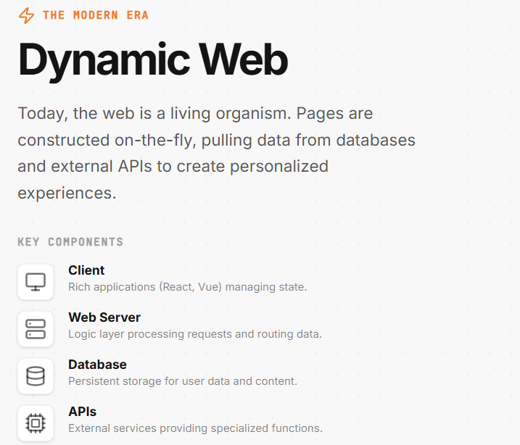
Dynamic websites are now integral to critical domains such as online banking, e-commerce, healthcare systems, and government services, where sensitive user data is constantly processed and transmitted. While this evolution has improved usability and functionality, it has also significantly expanded the attack surface of web applications. Each input field, API endpoint, and database query represents a potential entry point for malicious exploitation.
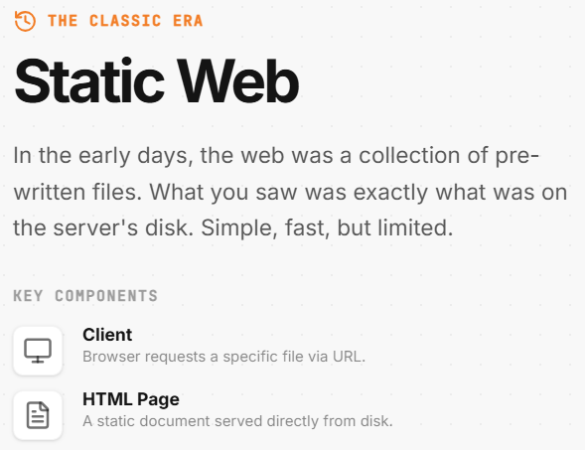
fuger(1.1)the classic era vs the modern era

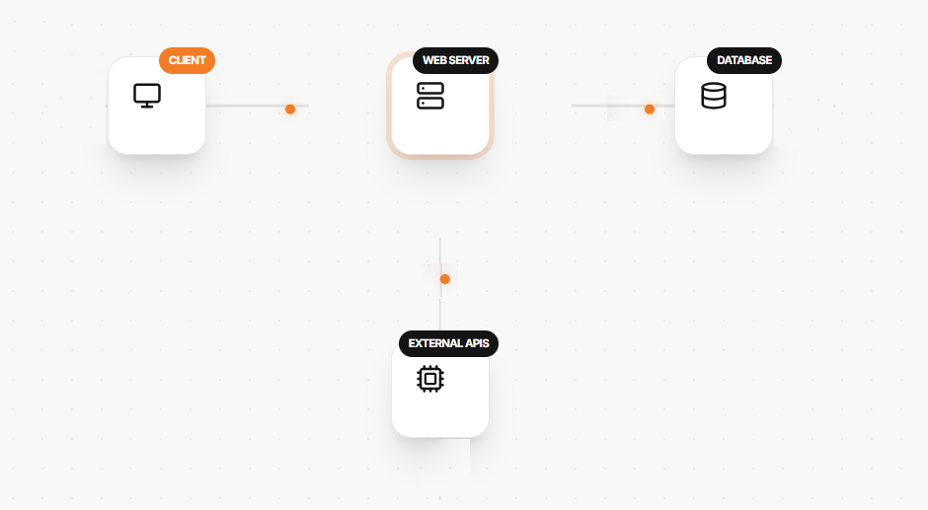
fuger(1.2)the classic era vs the modern era requests

One of the major challenges in securing dynamic web applications is their complex architecture, which often involves multiple layers such as:
- Frontend (User Interface)
- Backend (Application Logic)
- Database Systems
- Third-party integrations (APIs, payment gateways)
Each of these layers introduces its own set of vulnerabilities. For example, improper input validation in the backend can lead to SQL Injection, while insecure client-side scripts may expose the system to Cross-Site Scripting (XSS) attacks [2].
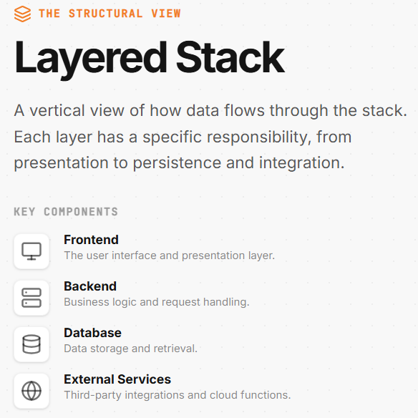
Figure 1.2: Multi-Layer Architecture of Web Applications

According to the OWASP Top Ten, web application vulnerabilities remain one of the most critical cybersecurity concerns worldwide. Common vulnerabilities include:
- Injection attacks (SQL, OS, LDAP)
- Broken authentication
- Sensitive data exposure
- Security misconfiguration
- Cross-Site Scripting (XSS)
These vulnerabilities are frequently exploited due to poor coding practices, lack of secure development lifecycle implementation, and insufficient testing [1].
Furthermore, traditional security approaches rely heavily on periodic vulnerability scanning, which is often insufficient for dynamic environments. Modern web applications are continuously updated, meaning that new vulnerabilities can be introduced at any time. Static scanning tools may fail to detect issues that arise due to:
- Runtime behavior
- User interactions
- Dynamic content rendering
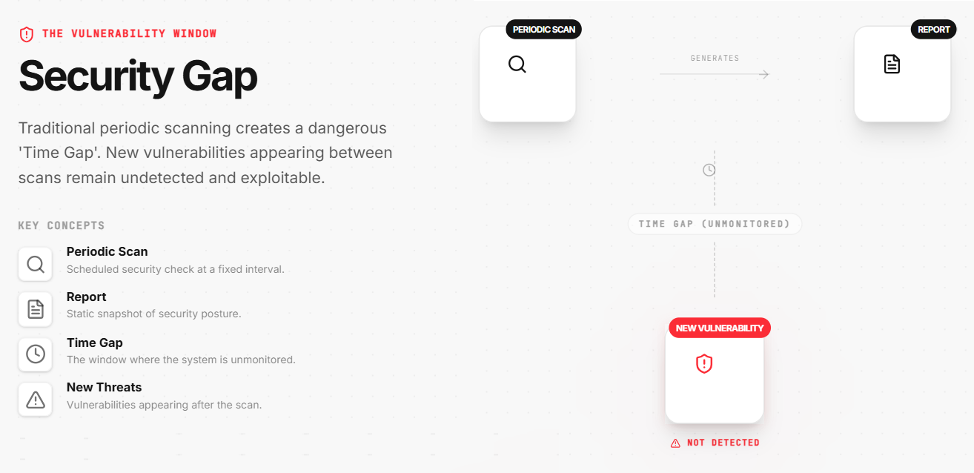
Figure 1.3: Limitations of Traditional Security Approaches

Another important factor is the rise of automated cyberattacks, where attackers use bots and scripts to scan thousands of websites for vulnerabilities within minutes. This has increased the need for automated and continuous monitoring systems capable of detecting threats in real time. Without such systems, organizations face delays in identifying and mitigating security risks, which can lead to:
- Data breaches
- Financial loss
- Reputation damage

According to NIST guidelines, continuous monitoring is a critical component of modern cybersecurity frameworks, enabling organizations to maintain situational awareness and respond quickly to emerging threats [3].

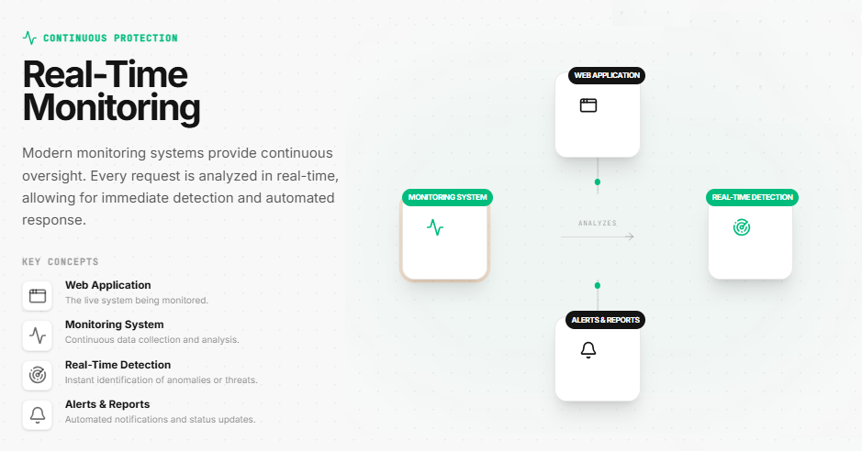

Figure 1.4: Continuous Monitoring Concept
In addition, the increasing adoption of DevOps and continuous deployment practices has accelerated the release cycles of web applications. While this improves innovation and responsiveness, it also introduces security challenges, as vulnerabilities may be deployed into production environments if not properly tested. This has led to the emergence of DevSecOps, which integrates security into every phase of the development lifecycle [4].
Despite these advancements, many existing solutions still lack:
- Real-time detection capabilities
- Integration with dynamic content
- Automated reporting systems
This highlights the need for a comprehensive web-based service that combines:
- Continuous monitoring
- Intelligent vulnerability detection
- Automated reporting mechanisms
Such a system can significantly enhance the security posture of web applications by reducing detection time and enabling proactive defense strategies.
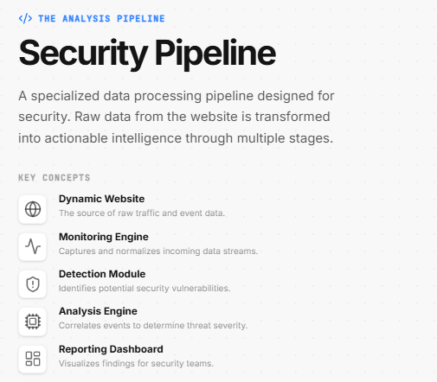
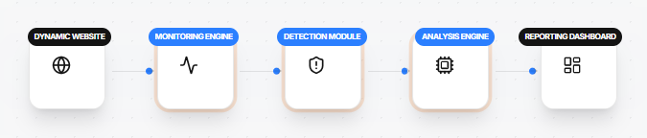
Figure 1.5: Proposed Smart Monitoring Approach
In summary, the increasing complexity of dynamic web applications, combined with evolving cyber threats, necessitates the development of advanced monitoring systems. A Dynamic Website Vulnerability Monitoring and Reporting Web Service provides an effective solution by ensuring continuous security assessment, real-time threat detection, and automated reporting, thereby addressing the limitations of traditional approaches.

1.2 Problem Statement
Most existing vulnerability detection systems suffer from several limitations:
- Lack of real-time monitoring
- Inability to detect vulnerabilities in dynamic content
- Absence of automated reporting mechanisms
- High dependency on manual security testing
These limitations create a need for an intelligent system capable of:
- Continuous monitoring
- Automatic vulnerability detection
- Real-time reporting

1.3 Aim of the Project
The main aim of this project is to design and implement a Dynamic Website Vulnerability Monitoring and Reporting Web Service that can:
- Monitor websites continuously
- Detect vulnerabilities automatically
- Generate real-time reports
- Improve overall web security

1.4 Objectives
The key objectives include:
- Develop a web-based monitoring system
- Implement automated vulnerability scanning
- Detect common vulnerabilities such as:
  - SQL Injection
  - Cross-Site Scripting (XSS)
  - Broken Authentication
- Provide real-time alerts and reports
- Ensure system scalability and performance

1.5 Scope of the Project
This project focuses on:
- Monitoring dynamic web applications
- Detecting known vulnerabilities using automated tools
- Generating reports for administrators

Limitations:
- Does not cover hardware-level attacks
- Limited to known vulnerability patterns
- Depends on scanning frequency

1.6 Significance of the Study
This system provides several important benefits:
- Enhances web security awareness
- Reduces manual effort in vulnerability detection
- Enables real-time response to threats
- Helps organizations comply with security standards

1.7 Methodology Overview
The system follows a structured approach:
- Data collection from web requests
- Vulnerability scanning
- Threat analysis
- Report generation

1.8 Structure of the Report
This report is organized as follows:
- Chapter 1: Introduction
- Chapter 2: Theoretical Background
- Chapter 3: Implementation
- Chapter 4: Conclusion and Future Work

Chapter Two
Theoretical Background

Chapter Two
Theoretical Background
2.1 Introduction
Web application security has become a critical research area due to the rapid growth of dynamic and data-driven web systems. As organizations increasingly rely on web platforms, the need for automated vulnerability detection, continuous monitoring, and real-time reporting has intensified.
This chapter presents a comprehensive review of:
- Existing research in web vulnerability detection
- Traditional and modern security approaches
- Tools and technologies used in this project

2.2 Literature Review
Over the past two decades, numerous approaches have been proposed to detect and mitigate web application vulnerabilities. These approaches can be broadly categorized into:
- Static Analysis
- Dynamic Analysis
- Hybrid Approaches
2.2.1 Static Analysis Techniques
Static analysis involves examining the source code without executing the application. Tools in this category analyze code patterns to identify potential vulnerabilities such as:
- SQL Injection
- Buffer overflows
- Improper input validation
According to research, static analysis is effective in early development stages but often produces false positives and cannot detect runtime issues [6].

Figure 2.1: Static Analysis Workflow
[Source Code]
↓
[Static Analyzer]
↓
[Vulnerability Report]

2.2.2 Dynamic Analysis Techniques
Dynamic analysis evaluates web applications during runtime by simulating real user interactions. It is widely used in penetration testing and vulnerability scanning tools.
Dynamic analysis can detect:
- Authentication flaws
- Session management issues
- Runtime injection attacks
However, it requires a running system and may miss hidden vulnerabilities not triggered during testing [7].

Figure 2.2: Dynamic Analysis Workflow

2.2.3 Hybrid Approaches
Hybrid techniques combine static and dynamic analysis to improve detection accuracy. These methods leverage the strengths of both approaches while minimizing their weaknesses.
Studies show that hybrid systems achieve better detection rates but require more computational resources and complex implementation [8].
Figure 2.3: Hybrid Analysis Model
2.2.4 Continuous Monitoring Systems
Traditional security testing is periodic, which creates a time gap where vulnerabilities may go undetected. Continuous monitoring systems aim to eliminate this gap by providing:
- Real-time detection
- Automated alerts
- Ongoing security assessment
According to NIST, continuous monitoring is essential for maintaining system security in modern environments [9].
Figure 2.4: Continuous Monitoring vs Periodic Testing
2.3 Technologies and Tools
This section describes the core technologies used in the implementation of the proposed system.
2.3.1 Django Framework
Django is a high-level Python web framework that enables rapid development of secure and maintainable web applications.
Django follows the Model-View-Template (MVT) architectural pattern and provides several built-in security features.
Key Features:
- Secure architecture by design
- Protection against:
  - Cross-Site Request Forgery (CSRF)
  - SQL Injection
  - Cross-Site Scripting (XSS)
- Built-in ORM (Object Relational Mapper)
- Scalable and modular structure
Figure 2.5: Django Architecture (MVT Pattern)
Django’s ORM abstracts database interactions, reducing the risk of injection attacks by using parameterized queries [10].
2.3.2 Nuclei Scanner
Nuclei is a modern vulnerability scanner developed by ProjectDiscovery. It is designed for fast and scalable scanning using template-based detection.
Key Characteristics:
- Uses YAML-based templates
- Supports detection of thousands of vulnerabilities
- Highly scalable
- Fast due to Go language concurrency

Figure 2.6: Nuclei Scanning Process
Nuclei enables automation by allowing users to define custom templates, making it highly flexible for different environments [11].

2.3.3 Celery and Redis
Celery is an asynchronous task queue used for handling background jobs, while Redis acts as a message broker.
Roles in the System:
- Celery:
  - Executes background tasks (e.g., scanning jobs)
  - Handles asynchronous processing
- Redis:
  - Stores task queues
  - Enables communication between services
Figure 2.7: Celery and Redis Workflow
This architecture improves system performance by offloading heavy tasks from the main application [12].

2.3.4 HTMX and Alpine.js
HTMX and Alpine.js are lightweight frontend technologies used to enhance interactivity.
HTMX Features:
- Enables dynamic updates without full page reload
- Uses HTML attributes for AJAX requests
Alpine.js Features:
- Simplifies JavaScript interactivity
- Lightweight alternative to larger frameworks

Figure 2.8: Dynamic UI Interaction
These tools improve user experience while maintaining simplicity and performance [13].

2.3.5 Docker
Docker is a containerization platform used to package applications and their dependencies.

Benefits:
- Environment consistency
- Easy deployment and scalability
- Isolation of services
Figure 2.9: Docker Container Model
Docker ensures that the application runs consistently across different environments, reducing deployment issues [14].

Chapter Three
Proposed System Design And Implementation
Chapter Three
Proposed System Design
And Implementation
3.1 Introduction
This chapter presents a deep dive into the proposed system design and implementation of the Vulnerability Assessment Web Service (VulnAssesor). The primary objective of this project was to create a system designed to be a comprehensive all in one web security hub that includes Static Application Security Testing (SAST) and Dynamic Application Security Testing (DAST) with advanced AI driven analysis.
This chapter presents a comprehensive review of:
- System Architecture
- Functional Workflows
- Database Design
- Implementation Environment and Tech Stack

3.2 System Architecture
The architecture of VulnAssesor is built to be following a modular and asynchronous “Team” design to ensure responsiveness during intensive security scans. Rather than treating the application as a monolithic whole, the system is organized as a coordinated team of specialized components and each component has a clearly defined responsibility and role to ensure high performance and scalability. This design allows the web interface to remain responsive while heavy and resource intensive tasks are running in the background.

- The Dashboard (Frontend): Built with Django Templates and enhanced by HTMX and Alpine.js. This provides a modern experience with real-time updates like live scan statuses without requiring full page reloads.
- The Manager (Backend): A Django 5.2 API server that acts as the “brain” It handles user requests, manages the database and dispatches jobs.
- The To-Do List (Message Broker): A Redis serves as the broker, connecting the Manager to Background Workers.
- The Workshop (Background Workers): Celery workers pick up tasks from Redis. These include a “Specialist” worker for DAST and a “Code Reviewer” worker for SAST
- The Filing Cabinet (Database): PostgreSQL database used for permanent storage of user data, scan results, and project configurations.
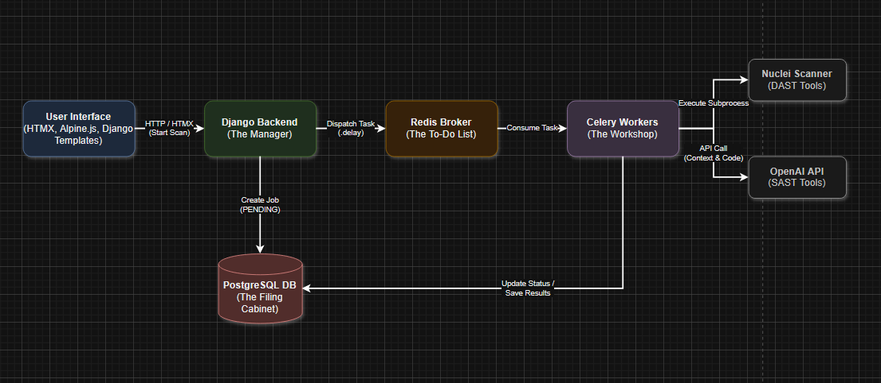
Figure 3.1: High-Level System Architecture Diagram
• The Dashboard (Frontend): Built with Django Templates and enhanced by HTMX and Alpine.js. This provides a modern, GitHub-inspired dark theme with real-time updates (like live scan statuses) without requiring full page reloads.
• The Manager (Backend): A Django 5.2 API server that acts as the "brain." It handles user requests, manages the database, and dispatches jobs.
• The To-Do List (Message Broker): Redis serves as the broker, connecting the Manager to the background workers.
• The Workshop (Background Workers): Celery workers pick up tasks from Redis. These include a "Specialist" worker for DAST and a "Code Reviewer" worker for SAST.
• The Filing Cabinet (Database): A PostgreSQL database used for permanent storage of user data, scan results, and project configurations
- Static Analysis a
- Dynamic Analysis
- Hybrid Approaches

References
[1] OWASP Foundation, OWASP Top Ten Web Application Security Risks, 2021.
[2] M. Howard and D. LeBlanc, Writing Secure Code, Microsoft Press, 2003.
[3] W. Stallings, Network Security Essentials, Pearson, 2017.
[4] D. Stuttard and M. Pinto, The Web Application Hacker's Handbook, Wiley, 2011.
[5] NIST, Guide to Web Security Testing, National Institute of Standards and Technology, 2018.
[6] B. Chess and G. McGraw, Static Analysis for Security, IEEE Security & Privacy, 2004.
[7] R. Lippmann et al., Evaluating Intrusion Detection Systems, DARPA, 2000.
[8] Y. Xie and A. Aiken, Static Detection of Security Vulnerabilities, USENIX, 2006.
[9] NIST, Information Security Continuous Monitoring (ISCM), 2018.
[10] Django Software Foundation, Django Documentation, 2024.
[11] ProjectDiscovery, Nuclei Documentation, 2024.
[12] Celery Project, Celery Distributed Task Queue Documentation, 2024.
[13] HTMX Organization, HTMX Documentation, 2024.
[14] Docker Inc., Docker Documentation, 2024.

